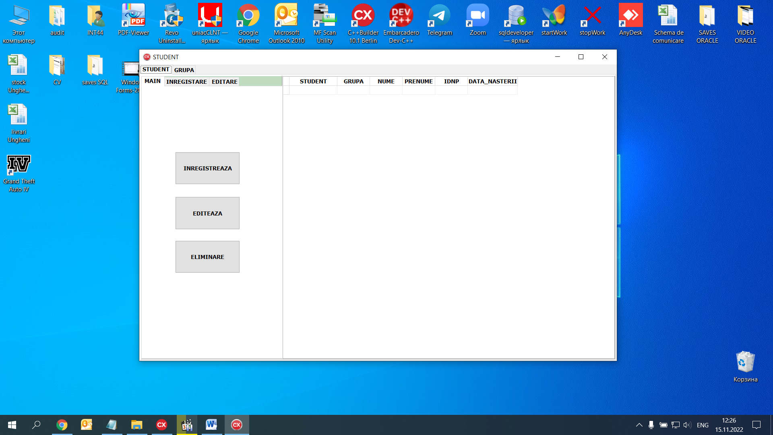

BUTON INREGISTRARE MAIN:

TabSheet3->TabVisible=false; //MAIN

TabSheet5->TabVisible=true;// INREGISTRARE STUDENT

TabSheet4->TabVisible=false;// EDITARE STUDENT

BUTON EDITARE MAIN:

Edit7->Text=DM->QSTUD->FieldByName("nume")->AsString;

Edit8->Text=DM->QSTUD->FieldByName("prenume")->AsString;

PASAGER_ID=DM->QSTUD->FieldByName("GRUPA_ID")->AsInteger;

Edit9->Text=DM->QSTUD->FieldByName("IDNP")->AsString;

DateTimePicker2->Date=DM->QSTUD->FieldByName("data_nasterii")->AsString;

TabSheet3->TabVisible=false; //MAIN

TabSheet5->TabVisible=true;// INREGISTRARE STUDENT

TabSheet4->TabVisible=false;// EDITARE STUDENT

BUTON ELIMINARE MAIN;

if(!DM->QSTUD->IsEmpty())

{

DM->QDEL_ST->Close();

DM->QDEL_ST->ParamByName("STUDENT_ID")->AsInteger=DM->QSTUD->FieldByName("STUDENT_ID")->AsInteger;

DM->QDEL_ST->ExecSQL();

DM->QSTUD->Close();

DM->QSTUD->Open();

}

else

ShowMessage("Nu sunt date de eliminat");

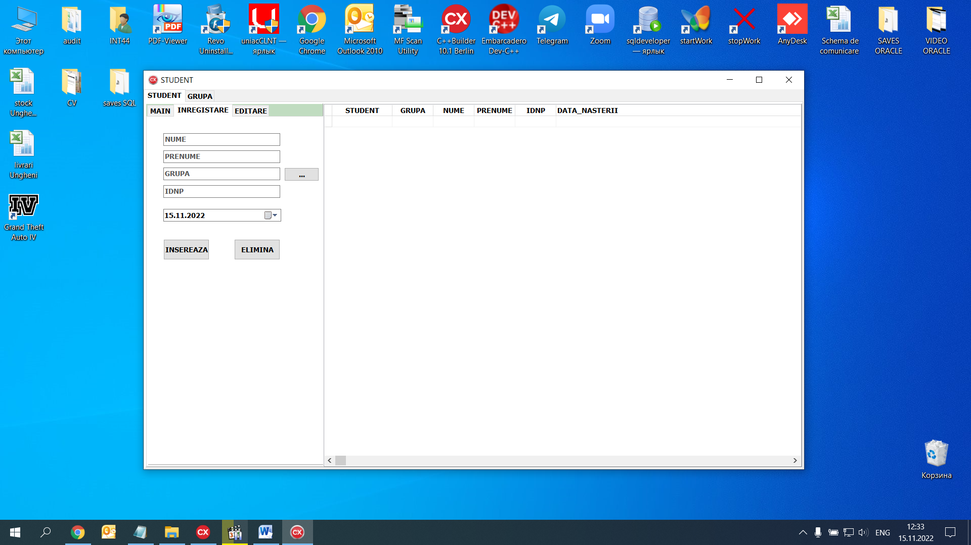

BUTONUL INSEREAZA GRUPA:

DM->QGRUPA->Close();

DM->QGRUPA->Open();

TabSheet6->TabVisible=true; //GRUPA

TabSheet4->TabVisible=false;// STUDENT

BUTONUL INSEREAZA IN INREGISTRARE:

DM->QINS_CL->Close();

DM->QINS_CL->ParamByName("NUME")->AsString=Edit3->Text;

DM->QINS_CL->ParamByName("PRENUME")->AsString=Edit4->Text;

DM->QINS_CL->ParamByName("DATA_NASTERII")->AsDate=DateTimePicker1->Date;

DM->QINS_CL->ParamByName("IDNP")->AsString=Edit5->Text;

DM->QINS_CL->ExecSQL();

Edit3->Clear();Edit4->Clear();Edit5->Clear();Edit6->Clear();

DM->QSTUD->Close();

DM->QSTUD->Open();

TabSheet3->TabVisible=false; //MAIN

TabSheet5->TabVisible=true;// INREGISTRARE STUDENT

TabSheet4->TabVisible=false;// EDITARE STUDENT

}

else

ShowMessage("Nu sunt introduse toate cimpurile");

BUTONUL ELIMINA:

TabSheet3->TabVisible=false; //MAIN

TabSheet5->TabVisible=true;// INREGISTRARE STUDENT

TabSheet4->TabVisible=false;// EDITARE STUDENT

BUTON EDITARE GRUPA

DM->QGRUPA->Close();

DM->QGRUPA->Open();

TabSheet6->TabVisible=true; //GRUPA

TabSheet4->TabVisible=false;// STUDENT

BUTONUL EDITEAZA:

if((Edit7->Text!="")&&(Edit8->Text!="")&&(Edit9->Text!="")&&(Edit10->Text!=""))

{

DM->QUPD_CL->Close();

DM->QUPD_CL->ParamByName("NUME")->AsString=Edit7->Text;

DM->QUPD_CL->ParamByName("PRENUME")->AsString=Edit8->Text;

DM->QUPD_CL->ParamByName("DATA_NASTERII")->AsDate=DateTimePicker2->Date;

DM->QUPD_CL->ParamByName("IDNO")->AsString=Edit9->Text;

DM->QUPD_CL->ParamByName("NR_PASS")->AsString=Edit10->Text;

DM->QUPD_CL->ParamByName("NOTA")->AsString=Memo2->Text;

DM->QUPD_CL->ParamByName("STUDENT_ID")->AsString=STUDENT_ID;

DM->QUPD_CL->ExecSQL();

Edit7->Clear();Edit8->Clear();Edit9->Clear();Edit10->Clear();

DM->QSTUD->Close();

DM->QSTUD->Open();

TabSheet3->TabVisible=false; //MAIN

TabSheet5->TabVisible=true;// INREGISTRARE STUDENT

TabSheet4->TabVisible=false;// EDITARE STUDENT

BUTON ANULEAZA:

Edit7->Clear();Edit8->Clear();Edit9->Clear();Edit10->Clear();

TabSheet3->TabVisible=false; //MAIN

TabSheet5->TabVisible=true;// INREGISTRARE STUDENT

TabSheet4->TabVisible=false;// EDITARE STUDENT

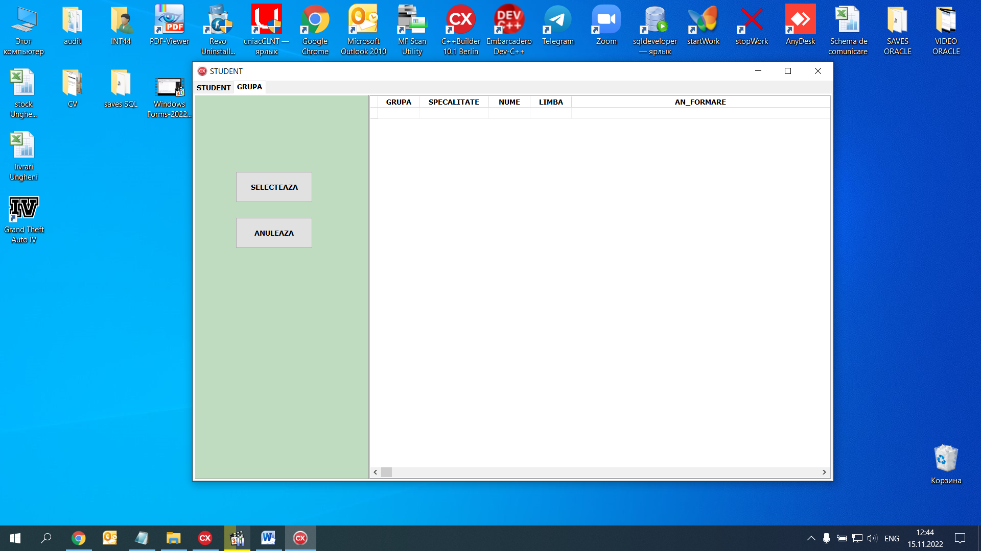

BUTON SELECTEAZA GRUPA:

TabSheet5->TabVisible=false; //STUDENT

TabSheet4->TabVisible=true;// GRUPA

GRUPA_ID=DM->QGRUPA->FieldByName("GRUPA_ID")->AsInteger;

Edit12->Text=DM->GRUPA->FieldByName("SPECIALIATE")->AsString;

Edit16->Text=DM->QGRUPA->FieldByName("NUME")->AsString;

Edit17->Text=DM->QGRUPA->FieldByName("LIMBA")->AsString

Edit18->Text=DM->QGRUPA->FieldByName("NUME")->AsString

Edit19->Text=DM->QGRUPA->FieldByName("AN_FORMARE")->AsString

BUTON ANULARE

TabSheet5->TabVisible=false; //STUDENT

TabSheet4->TabVisible=true;// GRUPA

**EAMEN WINDOWS FORMS**

**PARTEA 2**

1. 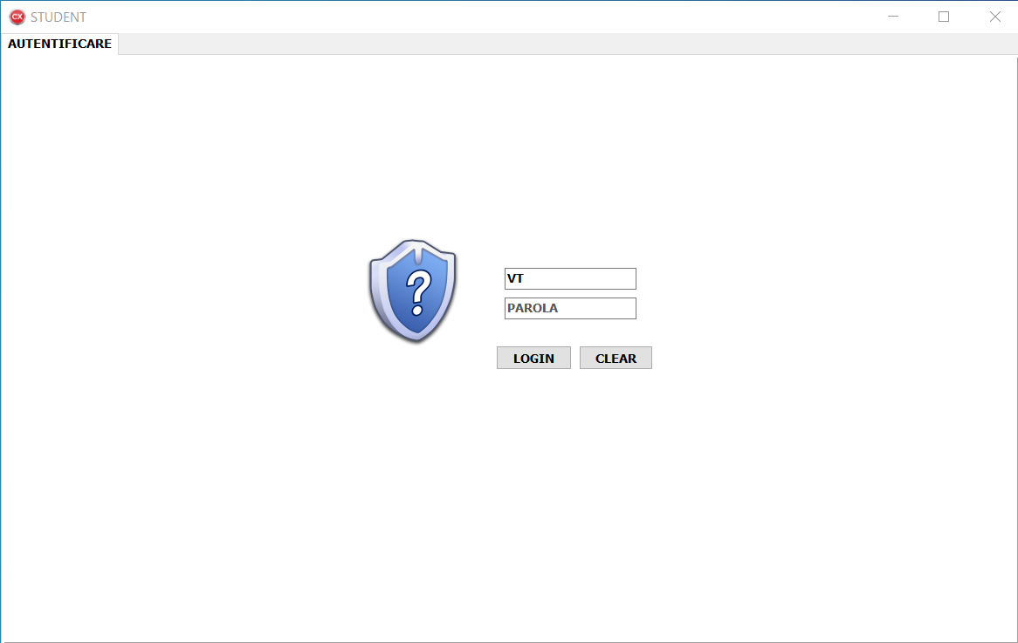

if((Edit9->Text!="")&&(Edit10->Text!=""))

{

DM->FQSTUDENT->Close();

DM->FQSTUDENT->SQL->Clear();

DM->FQSTUDENT->SQL->Add("SELECT * FROM STUDENT WHERE UTILIZATOR=:U AND PAROLA=:P");

DM->FQSTUDENT->ParamByName("U")->AsString=Edit9->Text;

DM->FQSTUDENT->ParamByName("P")->AsString=Edit10->Text;

DM->FQSTUDENT->Open();

if(!DM->FQSTUDENT->IsEmpty())

{

Ini->WriteString("Edit","utilizator",Edit9->Text);

// Label4->Caption=DM->FQSTUDENT->FieldByName("nume")->AsString+" "+DM->FQSTUDENT->FieldByName("prenume")->AsString;

DM->FQSTUDENT->Close();

DM->FQSTUDENT->Open();

DM->QGRUPA->Close();

DM->QGRUPA->Open();

TabSheet1->TabVisible=true;// pasager

TabSheet3->TabVisible=true;// main

TabSheet4->TabVisible=false;

TabSheet6->TabVisible=false;//

TabSheet2->TabVisible=false;//

TabSheet5->TabVisible=false;//

}

else

{

ShowMessage("Autentificare esuata");

}

}

else

{

ShowMessage("Nu sunt introduse datele de logare");

}

1. 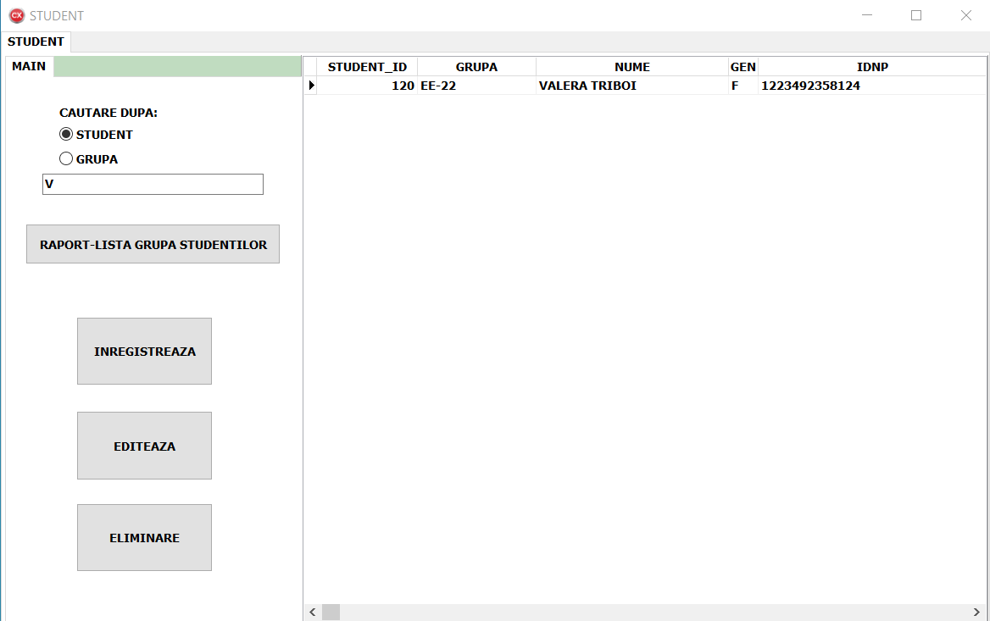

AnsiString s;

s=" SELECT *,S.NUME+' '+PRENUME AS NPP, ";

s+=" IIF(GEN=1,'M','F') AS GENN ";

s+=" FROM STUDENT S INNER JOIN GRUPA G ON S.GRUPA_ID=G.GRUPA_ID ";

if(Ecauta->Text!="")

{

if(RBS->Checked)s+=" where S.NUME like '"+Ecauta->Text+"%' ";

if(RBG->Checked)s+=" where G.NUME like '"+Ecauta->Text+"%' ";

}

s+=" ORDER BY S.NUME ";

DM->FQSTUDENT->Close();

DM->FQSTUDENT->SQL->Clear();

DM->FQSTUDENT->SQL->Add(s);

DM->FQSTUDENT->Open();

}

1. 